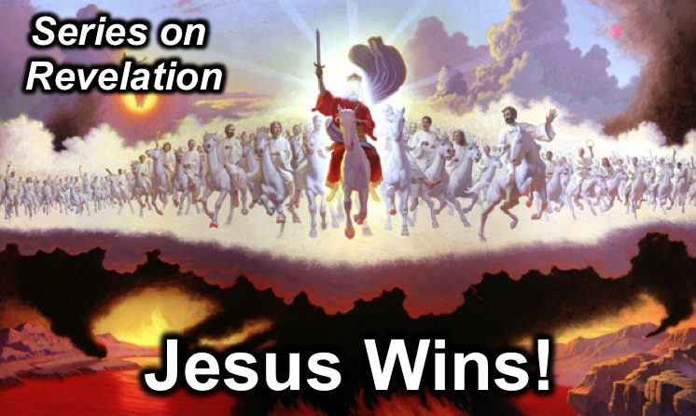
Lewis Winkler
2 February 2014
Message 9 of 20

Worthy of All Worship
Revelation 4

Introduction

- An Invitation to _________________ (4:1):

- An Invitation to _________________ (4:2-8a):

- An Invitation to _________________ (4:8b-11):

Conclusion and Application

Main Idea: God, the wondrous and sovereign Creator of all, is worthy of all worship.

Personal Application:

- What do your spend most of your time doing and thinking about and how do you spend most of your money?

- In view of this, who or what are you putting your trust and hope in to get you through the tough times of life?

- What will you do to reorient your life towards a greater trust in and worship of God?

Thought Questions for Further Reflection and Home Group:

- Take some time to read the passage out loud and share if there anything that surprises or confused you. If so, try to recall what is going on, and what the point of the chapter is.

- Take an honest look at your life. What does it tell you (and others) is most worthy of your time and attention? For example, what do you think about most of the time and how do your spending habits reveal your deepest priorities?

- Do you need to make some adjustments in these areas? If so, what? Be specific!

- What helps you most to worship God and reorient your life toward His sovereign goodness?

